Scribble to Digital

Project Description
The Scribble to Digital system is designed to convert handwritten notes into organized digital text using modern technologies such as image processing, Optical Character Recognition (OCR), and Artificial Intelligence.
Many students and professionals prefer writing notes by hand, but handwritten notes can be difficult to read, edit, or store digitally. The Scribble to Digital system addresses this problem by automatically processing handwritten images and transforming them into structured digital content.
The system first enhances the uploaded handwritten image using image preprocessing techniques to improve clarity and remove noise. After the image is processed, OCR technology extracts the text from the image. Since handwritten text may contain irregularities, the extracted text is further refined using an AI model that corrects grammar, reconstructs incomplete words, and improves the overall readability of the text.
Additionally, the system analyzes the content of the notes and automatically identifies important tasks or action items. These tasks are separated from the general text and displayed as a structured To-Do list.
This system helps users quickly convert handwritten information into digital format, making it easier to store, review, and manage notes efficiently.
Use Case Scenarios
The Scribble to Digital system can be used in several practical situations where handwritten notes need to be converted into digital format.
Scenario 1: Handwritten Note Digitization
Students and professionals can upload images of handwritten notes to convert them into digital text. The system enhances the image quality and extracts the written content using OCR technology, allowing users to easily read and store their notes in digital form.

Scenario 2: Text Correction and Formatting
The extracted text may contain errors due to variations in handwriting. The system uses an AI model to correct spelling mistakes, reconstruct incomplete words, and organize the text into clear sentences and paragraphs. This ensures that the final digital text is readable and well structured.
Scenario 3: Task Identification and To-Do List Generation
Handwritten notes often include reminders or tasks. The system automatically analyzes the extracted text and identifies action-oriented statements. These tasks are separated and presented as a structured To-Do list, helping users quickly identify important activities.
This allows users to quickly identify important tasks separately from general notes, improving productivity and task management.
Architecture Overview
Scribble to Digital is an intelligent AI-powered web application designed to convert handwritten notes into clean, structured digital text. The platform is built using the Streamlit framework, enabling rapid development of an interactive user interface.
The system integrates:
- Streamlit for frontend and application logic
- OpenCV for image preprocessing and enhancement
- OCR Engine (EasyOCR) for text extraction
- Google Gemini 2.5 Flash (Generative AI) for contextual correction, formatting, and task extraction
The platform processes handwritten images, enhances clarity, extracts text, corrects errors using AI, and optionally generates structured outputs such as formatted notes and to-do lists.

Core Technologies
- Streamlit: Interactive web application framework for UI, file uploads, and result display
- Google Gemini 2.5 Flash: AI model for contextual understanding, grammar correction, and smart task extraction
- OpenCV: Image preprocessing (grayscale conversion, noise removal, thresholding)
- OCR (TEasyOCR): Converts enhanced handwritten images into raw digital text
- Python: Core programming language

Component-Wise Architecture
Component | Description
Streamlit Frontend UI | Provides a simple web interface for users to upload handwritten images. Displays enhanced images, extracted text, corrected content, and to-do lists dynamically.
Image Processing Layer (OpenCV) | Enhances uploaded images by converting to grayscale, adjusting brightness/contrast, reducing noise, and applying thresholding to improve OCR accuracy.
OCR Layer | Extracts raw text from the processed image. Handles handwriting recognition and converts image content into machine-readable text.
Generative AI Layer (Gemini 2.5 Flash) | Processes extracted text to: • Correct spelling and grammar • Reconstruct incomplete words • Format into structured paragraphs • Extract actionable to-do items
Export Module | Converts AI-processed content into downloadable formats such as PDF or Word documents.

Pre-requisites
- Google AI Studio Account Setup – To generate Gemini API Key
- Python 3.8+ Installed
- Streamlit Framework Installed
- 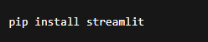
- Required Python Libraries
  - opencv-python
  - pytesseract /easyocr
  - google-generativeai
  - pillow
  - reportlab (for PDF export)
  - python-docx (for Word export)
- Tesseract OCR Installed (if using pytesseract)

Project Workflow

The Scribble to Digital system is designed to convert handwritten notes into structured digital text using image processing, OCR, and Artificial Intelligence. The system works through a sequence of processing steps to ensure accurate text extraction and organization

1. Gemini AI Setup & Initialization
Activity 1.1: Set up Google AI Studio with Gemini API
- Create or sign in to Google AI Studio account
- Generate API key for Gemini model access
- Enable Gemini 2.5 Flash model

Activity 1.2: Configure API Keys and Environment
- Store GEMINI_API_KEY securely in .env file
- Load environment variables using python-dotenv
- Validate API connectivity inside Streamlit app

2. Uploading the Handwritten Image

- The user begins by uploading an image containing handwritten notes through the application interface.
- This image serves as the input for the system.

3. Image Preprocessing

- After the image is uploaded, the system enhances the image quality using preprocessing techniques such as grayscale conversion, brightness adjustment, and noise reduction.
- These steps help improve the clarity of the text in the image.

4. Text Extraction using OCR

- The enhanced image is then processed using Optical Character Recognition (OCR) technology.
- OCR analyzes the image and converts the handwritten characters into machine-readable text.

5. AI-Based Text Correction
- Since handwritten text recognition may contain errors, the extracted text is analyzed using an Artificial Intelligence model.
- The AI corrects spelling errors, reconstructs incomplete words, and improves the readability of the text.

6. Task Identification

- The system further analyzes the refined text to identify important tasks or action-oriented sentences present in the notes.

7. Displaying the Final Output

- Finally, the system displays the corrected digital text along with a structured To-Do list containing the extracted tasks.
- This allows users to easily read and manage their handwritten information.

8. Testing & Optimization

Activity 4.1: Functional Testing
- Test with:
  - Clear handwriting
  - Messy handwriting
  - Mixed text + tasks
  - Bullet points
- Validate OCR accuracy
- Validate AI corrections

Activity 4.2: Evaluate AI Response Quality
- Check:
  - Grammar correction accuracy
  - Logical sentence flow
  - Proper formatting
  - Correct task extraction
- Ensure no hallucinated content

MILESTONE 1: Generative AI Initialization
Project: Scribble to Digital (Streamlit Framework)
In this foundational stage, the objective is to establish and configure the AI infrastructure required to power the Scribble to Digital application.
The platform uses Gemini 2.5 Flash, Google’s fast and efficient multimodal model, to:
- Correct messy handwritten OCR text
- Improve grammar and sentence flow
- Reconstruct incomplete words
- Extract structured to-do tasks
- Convert handwritten notes into clean digital format
Activity 1.1: Set up Google AI Studio and Enable Gemini API
1. Sign in to Google AI Studio
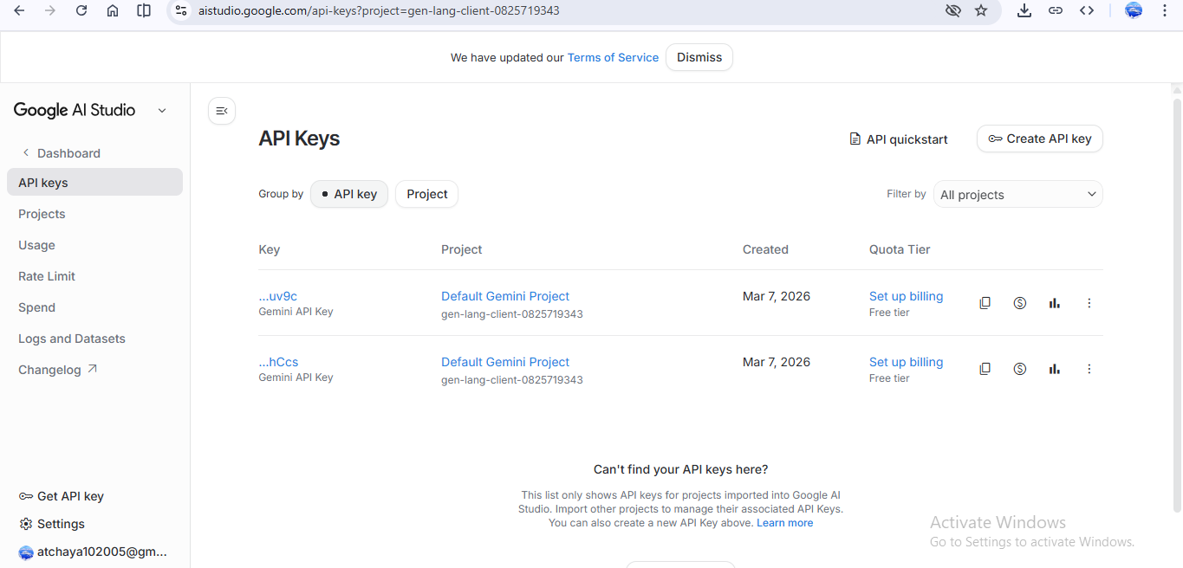
- Visit: https://makersuite.google.com/app/apikey
- Sign in with your Google account
- Accept terms and conditions
2. Create API Key
- Click "Create API Key"
- Copy the generated API key
- Store it securely in a .env file
3. Select Model
Choose: Gemini 2.5 Flash
Model Features:
- Fast response time
- Efficient token usage
- Suitable for text correction & formatting
- Free tier supports multiple requests per minute
Best for:
- OCR text cleaning
- Contextual rewriting
- Structured note generation
Activity 1.2: Configure Environment and Test Connection (Streamlit Setup)

Step 1: Create. env File
Inside your project folder:
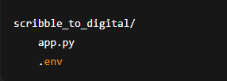

Add:
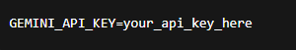

Step 2: Install Required Dependencies
Libraries Used:
- streamlit → UI framework
- google-generativeai → Gemini API integration
- python-dotenv → Load environment variables
- opencv-python → Image preprocessing
- pytesseract → OCR text extraction
- pillow → Image handling
MILESTONE 2: Core Functionalities Development (Streamlit)
This milestone focuses on building the complete working application using Streamlit + Gemini 2.5 Flash.
The goal is to:
- Upload handwritten note images
- Extract text using OCR
- Clean & correct text using Gemini
- Extract tasks automatically
- Display structured digital output
- Enable download options
MILESTONE 3: Backend – Flask Integration (app.py)
This milestone focuses on implementing the complete Flask backend for the Scribble to Digital application, including OCR processing, GenAI integration, task extraction, error handling, and export functionality.
Activity 3.1: Complete Route Definitions
All routes are properly defined with:
1. Input Validation
- Validates uploaded image file type (.jpg, .png, .jpeg)
- Checks for empty file upload
- Validates file size limit
- Ensures image can be processed
2. Error Handling
- Handles OCR processing errors
- Handles Gemini API failures
- Returns proper JSON error responses
- Prevents server crash on invalid input
3. Logging
- Logs image upload events
- Logs OCR extracted text
- Logs GenAI responses
- Logs export operations
- Debug logs for development mode

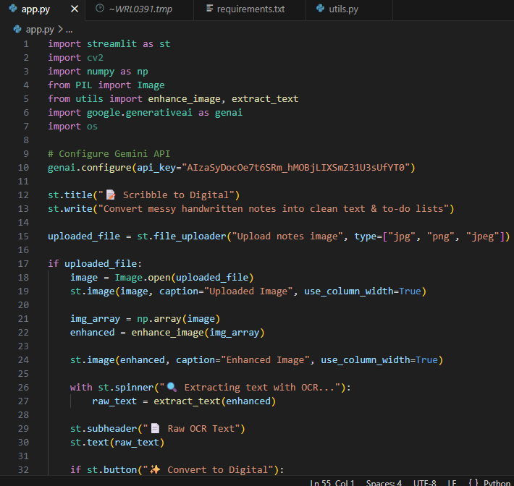
Activity 3.3: Export Implementation
Complete implementation of:
1. PDF Generation
- Clean formatted digital notes
- Structured to-do list section
- Professional layout
- Downloadable file
2. Word Document Export (.docx)
- Heading styles
- Bullet points for tasks
- Editable format
3. CSV Export (Task List)
- Task column
- Status column (Pending/Done)
- Compatible with Excel
4. File Cleanup & Management
- Temporary file storage
- Auto-delete after download
- Secure file handling

MILESTONE 4: UI Development
This milestone focuses on building a modern, responsive, and interactive frontend interface using Streamlit for the Scribble to Digital application.
The UI allows users to:
- Upload handwritten notes
- Process them using OCR + Generative AI
- View structured digital output
- Download formatted results
Activity 4.1: Landing Page Development
Home Page: Transform Your Notes into Digital Intelligence
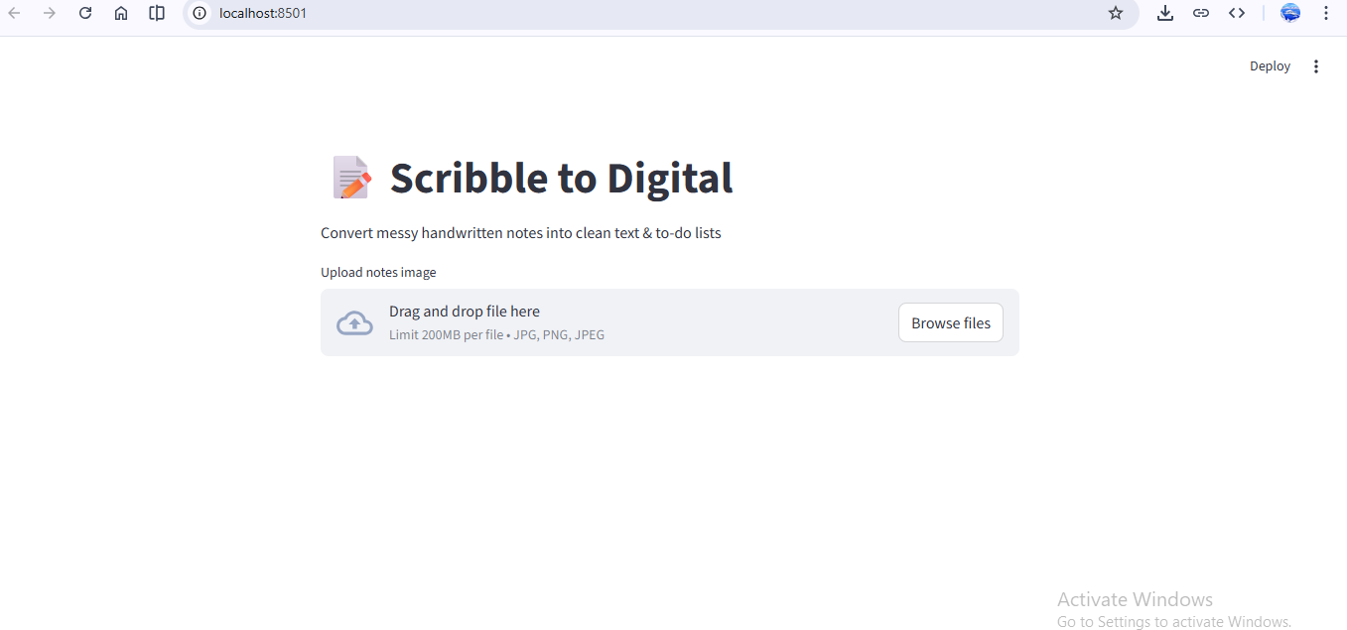
🔹 Hero Section
Title:
✍️ Transform Your Handwritten Notes into Smart Digital Content
Subtitle:
Convert messy notes into clean text and structured to-do lists using OCR and AI.
🔹 Feature Cards Section
Using Streamlit columns layout:
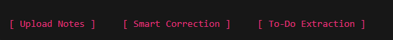
1. Upload Notes
- Accept handwritten image
- Supports JPG, PNG, JPEG
- Instant preview

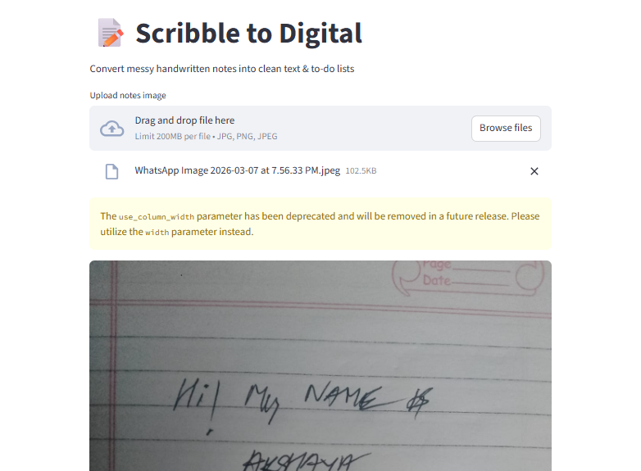

2. Smart Correction
- Fixes spelling mistakes
- Uses contextual AI logic
- Improves readability
3. To-Do Extraction
- Identifies action items
- Converts tasks into list format
- Separates notes from tasks
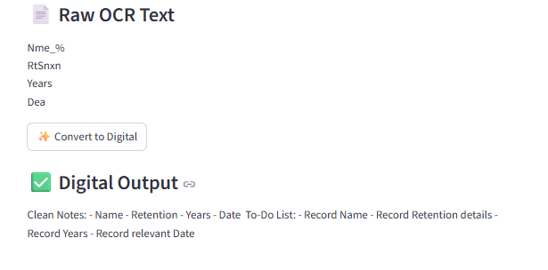
Activity 4.2: Processing Page (Main Generator Page)
Handwritten Notes Processing Page
Input Fields:
- Image Upload Section
- Convert Button
- Reset Button
UI Layout (Streamlit Flow)
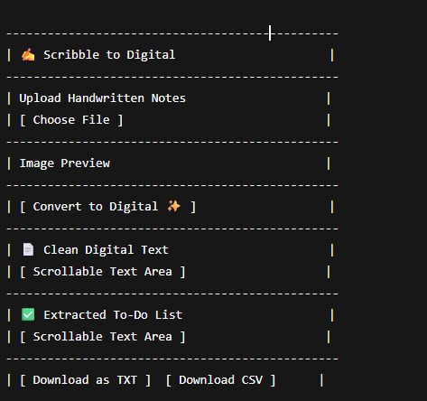
Activity 4.4: Export Interface
Export Options:
- Download Clean Text (.txt)
- Download Task List (.csv)
- Future enhancement: PDF export.
Activity 4.5: UI Design Principles Applied
- Clean card-style sections
- Proper spacing
- Clear section separation
- User feedback (spinner, success message)
- Mobile responsive (Streamlit auto-adjusts)
- Logical workflow design
Complete User Interaction Flow
- User opens application.
- Views landing page with features.
- Navigates to processing page.
- Uploads handwritten image.
- Clicks convert.
- Views:
  - Clean text
  - Extracted tasks
- Downloads results.

MILESTONE 5: Testing & Optimization
Scribble to Digital – Handwritten Notes Digitizer
This milestone focuses on comprehensive testing, quality validation, and performance optimization of the Scribble to Digital application to ensure accuracy, reliability, and smooth user experience.
Activity 5.1: Comprehensive Testing
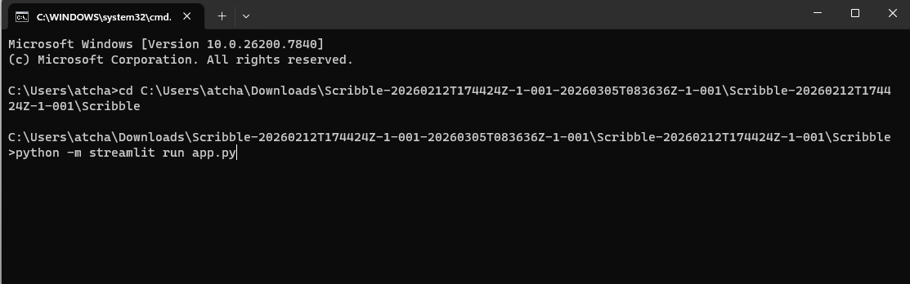
Test Scenarios
Test Scenario 1: Medium Quality Handwriting
- Slight shadows
- Minor spelling distortions
- Mixed notes and tasks
Expected Result:
- OCR extracts readable text
- AI corrects spelling using contextual logic
- Tasks are properly separated
Outcome:
The AI improved sentence clarity and successfully identified most tasks.
Test Scenario 2: Poor Quality Image
- Blurry text
- Low brightness
- Irregular handwriting
Expected Result:
- Partial text extraction
- Context-based correction
- Limited but usable output
Outcome:
Image enhancement improved visibility, and the AI generated partially corrected readable text.
Test Scenario 3: Notes Without Tasks
- Informational notes only
- No action keywords
Expected Result:
- Clean digital text
- No tasks detected
Outcome:
System correctly displayed cleaned notes and returned “No tasks detected”.

Conclusion
The Scribble to Digital system provides an effective solution for converting handwritten notes into structured digital text. By combining image pre-processing, OCR technology, and Artificial Intelligence, the system can accurately extract and refine handwritten content.
The application not only converts handwritten notes into readable digital text but also identifies important tasks and organizes them into a structured To-Do list. This helps users save time and manage their information more efficiently.
Overall, the system demonstrates how modern technologies can be used to simplify the process of digitizing handwritten notes and improving productivity.
With modular architecture, effective error handling, and optimized performance, Scribble to Digital demonstrates how AI can bridge the gap between handwritten creativity and digital productivity. Whether used by students, professionals, or teams, the application serves as a smart assistant that enhances organization, improves clarity, and streamlines everyday workflows.

